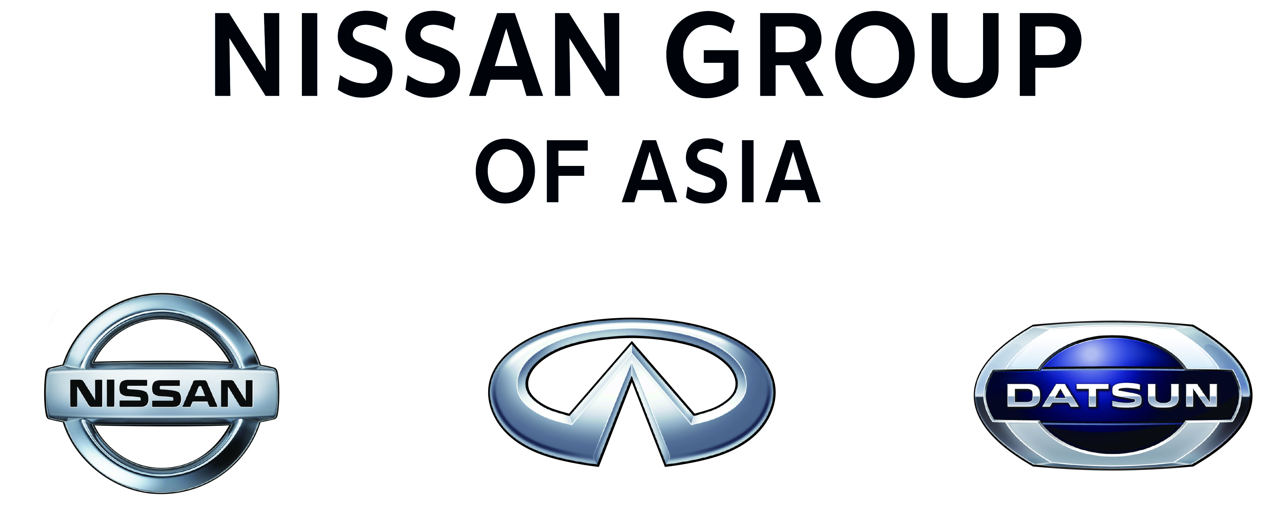

NISSAN SET TO THRILL ‘AUTO CHINA 2014’
WITH NEW SEDAN CONCEPT

- World premiere of a new sedan concept that embodies Nissan’s global design strategy and strong commitment to China as one of Nissan’s most important markets
- Cutting-edge vehicles and technologies on display, such as the BladeGlider concept and Autonomous Drive car
- Nissan’s flagship sedan, Teana, celebrates its 10th anniversary in China
- Further evolution of Nissan’s global motor show booth with three-layer theater style
- Interactive communication with booth visitors using “Augmented Reality” during public days

HONG KONG, China (March 10, 2014) – Nissan is ready to shake up the 13th Beijing International Automotive Exhibition (Auto China 2014).
Auto China 2014 runs from April 20 (press day) to April 29 at the China International Exhibition Center in Beijing. Nissan (China) Investment Co., Ltd. (NCIC), in cooperation with Dongfeng Nissan Passenger Vehicle Company (DFL-PV) and Zhengzhou Nissan Automobile Co., Ltd. (ZNA), will present an exciting line-up of more than 20 vehicles at Asia’s largest motor show of the year.
The star of the show will be a new sedan concept which will make its world premiere. Also featured will be the BladeGlider concept, making its Chinese debut, and Nissan’s latest global innovations, including the Autonomous Drive car.
Teana, Nissan’s flagship sedan, celebrates its 10th anniversary in China this year and a special edition Teana will be on display. The two latest introductions, the all-new X-Trail and the new NV200 Xtronic® transmission, are expected to draw attention from booth visitors.

Nissan will deliver to Auto China 2014 a further-evolved global motor show booth with a distinctive three-layer theater style. During public viewing days, visitors will be able to experience new interactive communications through “Augmented Reality” technology.
Media Center and site information will be available online starting today at http://www.nissan.com.cn/media_center/autoshows/2014/beijing/en. Look for the latest news to be uploaded regularly at this URL until the end of the exhibition.

New Sedan Concept
Last year at Auto Shanghai 2013, Nissan unveiled the Friend-ME concept, attracting attention from both the media and the Chinese “Post-80s” generation through its provocative design and connectivity features. This year at Auto China 2014, Nissan will reveal a new sedan concept for the Chinese digital lifestyle. The concept expresses Nissan’s passion and focus in the world’s most dynamic auto market.
Subsequent to Friend-ME in 2013, this concept car will be the second time for Nissan Design China (NDC), Nissan’s newest global design center located in Beijing, to realize a concept car design in collaboration with the Nissan Global Design Center (NGDC) under the leadership and direction of Nissan Senior Vice President and Chief Creative Officer Shiro Nakamura.

BladeGlider Concept
BladeGlider redefines the driving experience with a unique center seat driver position, giving drivers and passengers alike a sense of automotive gliding. Highly aerodynamic, the narrow front and stable rear track reduce drag while generating downforce. The result is a powerful combination of road-hugging agility and hyper-efficiency. Heralded by global media as “cutting edge” and “awesome,” BladeGlider will make its local debut at Auto China 2014.
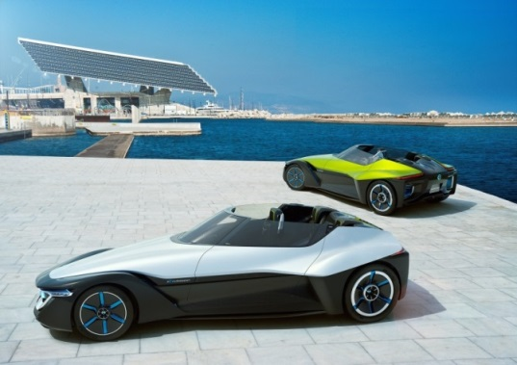

Autonomous Drive Car
Nissan revealed the autonomous driving technology in August 2013 when the company committed to being ready with multiple, commercially viable Autonomous Drive cars by 2020. The system will be deployed across the model range within two vehicle generations. Nissan's Autonomous Drive technology is an extension of its Safety Shield, which monitors a 360-degree view around a vehicle for risks, offers warnings to the driver and takes action if necessary.
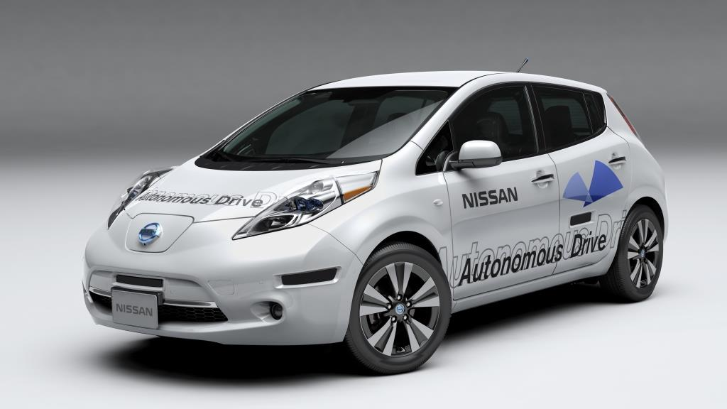

Teana 10th Anniversary Special Edition
Celebrating the 10th anniversary of Teana in China, a special edition of Nissan’s global flagship sedan will be revealed at Auto China 2014. Teana has been leading the premium sedan segment in China, thanks to its class-above driving experience, combining comfort and agility.
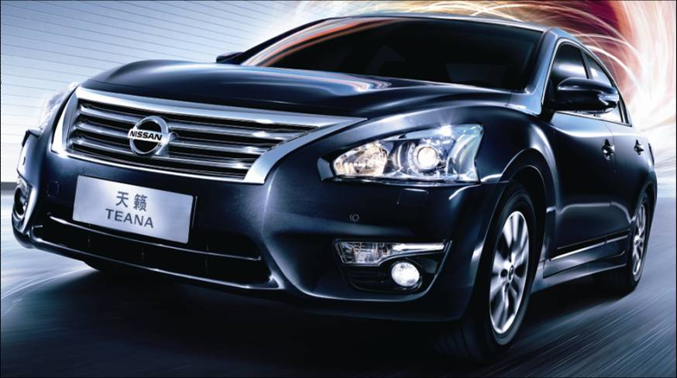

All-New X-Trail
Following a successful unveil in China last month, the all-new X-Trail will be available for sale in late March and is expected to lead the growing SUV segment in China. Featuring a large console box for gear and flexible seating that can be configured in several ways to best accommodate cargo and passengers, X-Trail is spacious and user-friendly. Its spinal support seats are first in class, as are the Active Trace Control and 4x4i drive system, with Hill Start Assist, Advance Hill Descent Control and Yaw Moment Control.
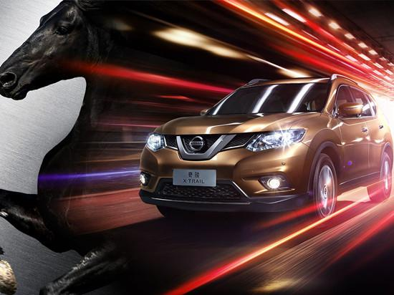

NV200 Xtronic® transmission
Growing in popularity since its launch earlier this year to the worldwide taxi industry including New York and London, Nissan will showcase the innovative NV200 Xtronic® transmission at Beijing. Just launched in China in late February, the model is equipped with the innovative Xtronic® transmission system which reduces noise levels and fuel consumption, delivering benefits for drivers, passengers and the environment alike.
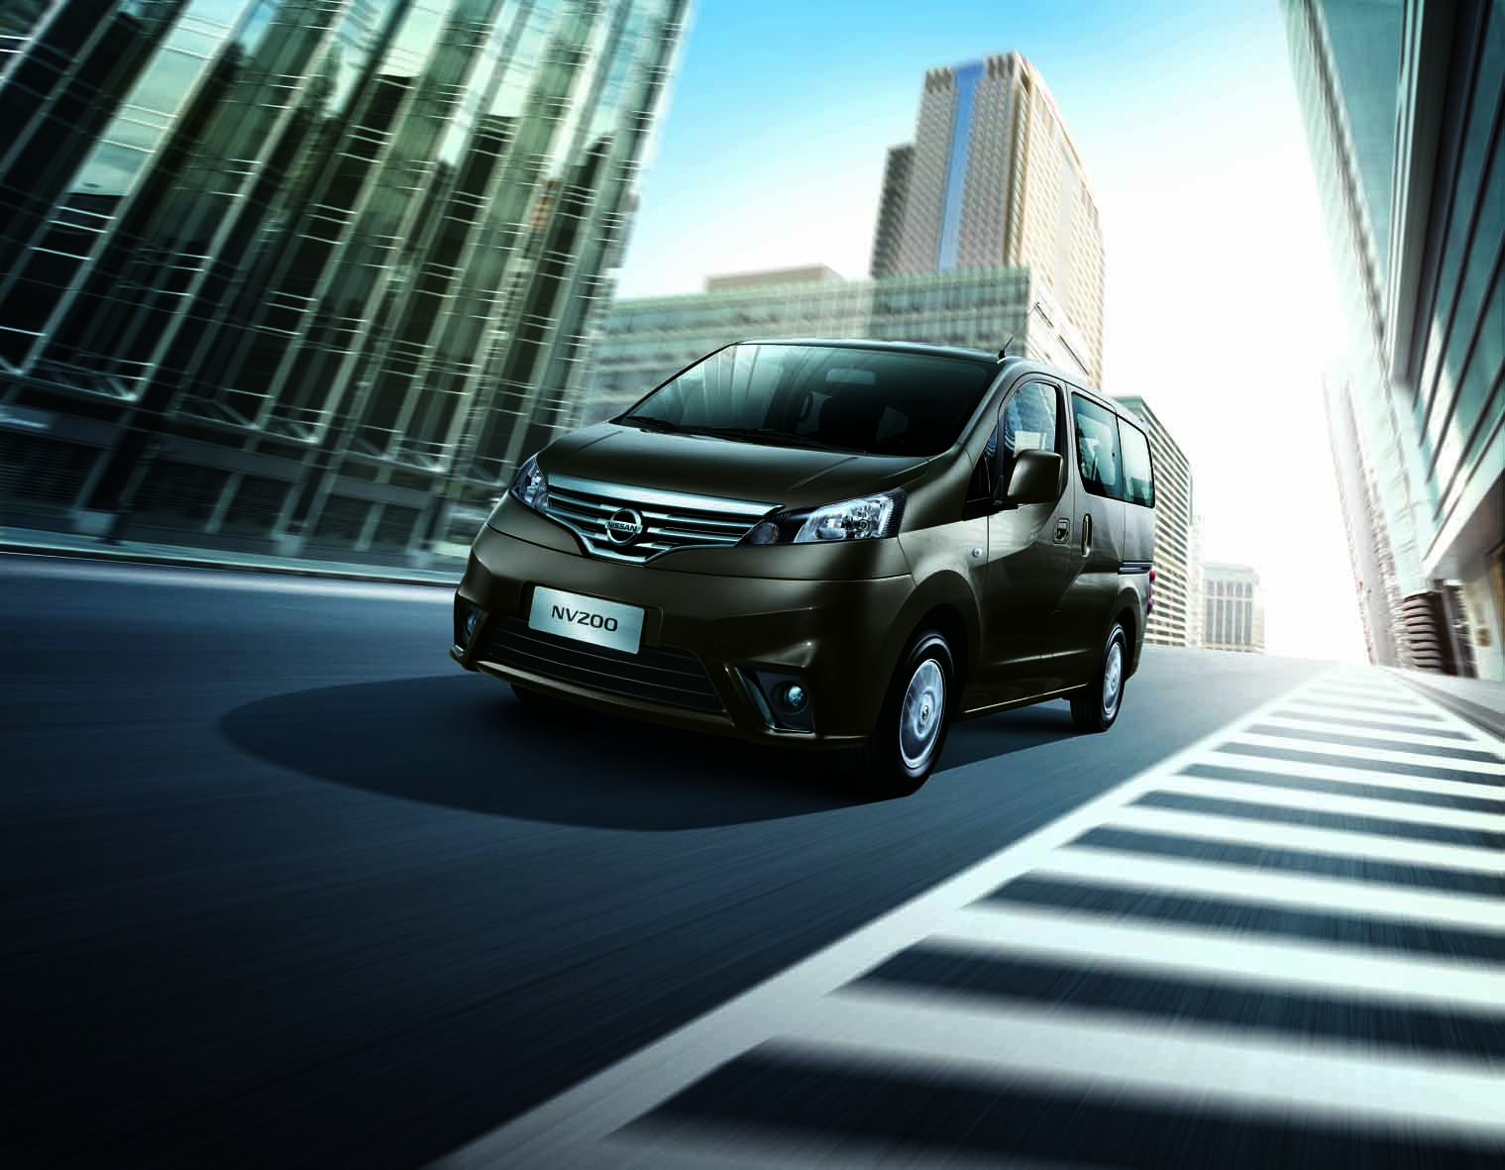

# # #

About Nissan Motor Co., Ltd.
Nissan Motor Co., Ltd., Japan's second-largest automotive company, is headquartered in Yokohama, Japan, and is part of the Renault-Nissan Alliance. Operating with approximately 236,000 employees globally, Nissan sold more than 4.9 million vehicles and generated revenue of 9.6 trillion yen (USD 116.16 billion) in fiscal 2012.
Nissan delivers a comprehensive range of more than 60 models under the Nissan and Infiniti brands. In 2010, the company introduced the Nissan LEAF, and continues to lead in zero-emission mobility. LEAF, the first mass-market, pure-electric vehicle launched globally, is now the best-selling EV in history.
For more information on our products, services and commitment to sustainable mobility, visit our website at http://www.nissan-global.com/EN

About Dongfeng Nissan Passenger Vehicle Company (DFL-PV)
Dongfeng Nissan Passenger Vehicle Company (DFL-PV) is a business unit of Dongfeng Motor Co., Ltd. (DFL), Nissan's joint venture with Dongfeng Motor Group Co., Ltd. DFL-PV is engaged in research and development operations, manufacturing and distribution of passenger vehicles.

About Zhengzhou Nissan Automobile Co., Ltd. (ZNA)
Founded in 1993, Zhengzhou Nissan Automobile Co., Ltd. is one of the largest manufacturers of light commercial vehicles (LCV) in China. Through the Nissan and Dongfeng brands, ZNA markets five series and eight models.

Media contacts:
Joyce CHENG
Tel: +852-9447-9965
Email: joyce.cheng@nissan.hk

Takeshi CHIBA
Tel: +852-3948-0142
Email: takeshi.chiba@nissan.hk

Nissan Global Co., Ltd.
Communications - China, Asia and Oceania
34F/36F, Citibank Tower, No. 3 Garden Road, Hong Kong

